WILLIAM
Contents

Overview 2
Student Profile 6
Student Profile – Teacher’s Guide to Interpreting the Data 7
Study Habits Checklist 8
Study Habits Checklist – Teacher’s Guide to Interpreting the Data 10
Identifying Your Learning Style 12
Strategies 13
Identifying Your Learning Style – Teacher’s Guide to Interpreting the Data 14
Summary of Student Assessment Data Worksheet 15
Analysis of Student Data Worksheet 17
Action Plan 18
Complete the Action Plan 23
Test 2 26
Analyze and Interpret the Comparison Graphs (Test 1 and Test 2) 29
Update the Action Plan – Test 2 31

Overview

Let us introduce William. We will take you through a typical 15-week semester and show you how we worked with him.
William grew up in an Anglophone family in Montreal and completed all his schooling in French immersion. He was successful in school and knew from a young age that he wanted to have a career in health care. He was accepted into the Nursing program directly from high school. We met William in his second year of Nursing when he was in the Childbearing and Childrearing Family course.
Week 5 William writes Test 1.
Week 7 Following his Test 1 mark of 58%, we sent William an Invitation to PASS via email.
Once William agreed to participate, we sent him all of the Complementary Assessment Tools (Student Profile,
Study Habits Checklist, and Identifying Your Learning Style), with a request that he complete and return them to us before the agreed upon meeting date.
Week 8 In the meantime, we reviewed William’s Student Performance Assessment Graphs (SPAG) from Test 1.
As you can see below, William received a mark of 58% on the test (passing grade: 60%). While this is a failing grade, remember that we want to focus first on his strengths, as this will engage him in the process and help him start to build confidence.
As we look closely at this SPAG, we see some areas where he is performing well.
Class Content
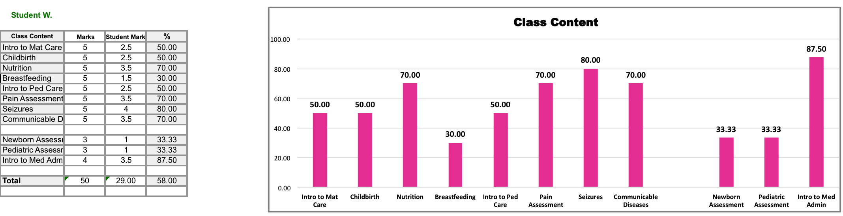
When we looked at William’s graph, our first impression was that it was a mixed performance with no clear pattern.
To interpret his graph, let us focus first on the subjects where William did well: Intro to Medication Administration Lab, Seizures, Nutrition, Pain Assessment in Maternal Care, and Communicable Diseases. In these areas, which seem to be more physical science-based, William’s marks ranged from 70% to 88%. He should be congratulated for his strong performance. The remaining subjects, where he did poorly – Intro to Maternal Care, Childbirth, Breastfeeding, Intro to Pediatric Care, Newborn and Pediatric Assessment Labs – appear to be more human science-based. Here, we see a range from 30% to 50%.
A picture is starting to emerge. William is doing well in the physical science-based classes as compared to the human science-based ones. This suggests that he has a strong science background. However, given the nature of some of the topics in a Perinatal Care and Pediatrics course, it has been our experience that young students may have difficulty when first exposed to this material. These interpretations will require validation with William.
Professional Component
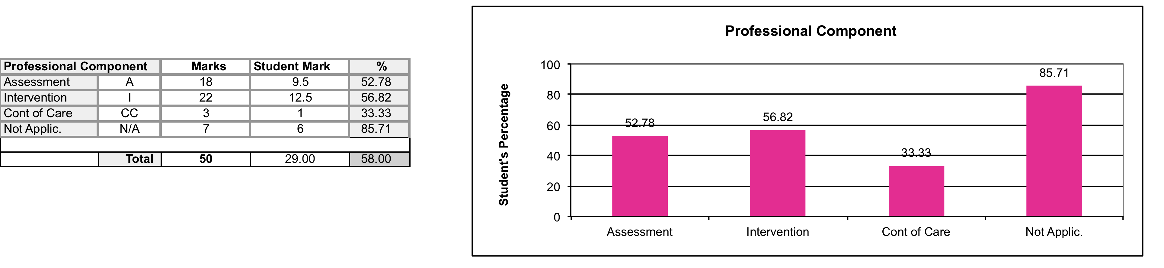
Recall that William received 58% on the test, which is very close to a passing mark. He performed best on Not Applicable questions (86%). While this is a strong performance, the Not Applicable variable accounted for only 14% of the test. It is a catch-all grouping of questions that, on this test, include medication-calculation questions and pathophysiology questions that are not related to a nursing activity. This reflects William’s strength in the physical science-based content that we saw in the previous graph.
The Professional Component provides us with the most information about the student’s ability to use their nursing knowledge. William has failed in both the Assessment and Intervention portions of the test, which suggests a weak knowledge base. This is our main concern, because Assessment-type and Intervention-type questions represent the majority of any nursing test. Unless he shows improvement in this area, William will ultimately fail the course.
William was least successful on Continuity of Care-type questions (33%). While this is also an area that needs improvement, it makes up only 6% of the test and is therefore an area of less concern. In our experience, when students improve in Assessment-type and Intervention-type questions, improvement in Continuity of Care questions usually follows.
Functional Component
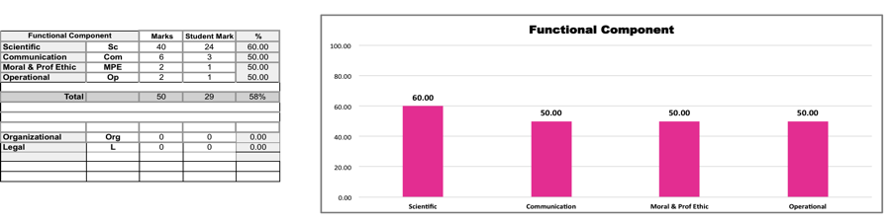
Let us start with the Scientific Field of Knowledge. Since this is the foundation of nursing practice, it is the predominant portion of any nursing test. William received a mark of 60%, which is congruent with his performance in the Professional Component category. It seems that William has the beginnings of a knowledge base but either there are gaps in his knowledge or he has difficulty using his knowledge to answer test questions.
The Communication Field was the second most tested field. Communication, an essential part of nursing, can be a difficult topic to test and answer. William’s score was 50%. Because we know that he grew up in an Anglophone family, we can assume this is not a language issue. It reflects our hypothesis that he is having more difficulty with the human science-based test questions, but this still needs to be validated with William. We should keep in mind that he is a young man who entered the Nursing program directly from high school. His difficulty answering Communication questions may be related to a lack of experience in these Fields of Nursing (Perinatal Care and Pediatrics courses).
William did not do well on the Moral and Professional Ethics and Operational Fields of Knowledge (50%). Because it is difficult to discern patterns from two questions per field, it might be tempting to disregard these results. However, all Fields of Knowledge are important. In order to help William, we need to look at where and why he lost marks. As you can see, the Legal and Organizational Fields of Knowledge were not tested.
Bloom’s Taxonomy
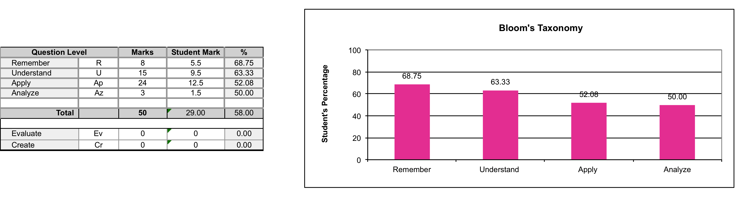
We can see from William’s SPAG that he did well on Remember-level (69%) and Understand-level questions (63%). Had the test contained only these two levels of questions, he would have passed. However, his performance shows a downward trend, from the simplest level of questions to the most complex.
This suggests, as we hypothesized in the Functional Component, that he does have a basic knowledge but has difficulty using this knowledge to apply and analyze a clinical situation. He needs to both build on his knowledge base and learn how to apply it in answering test questions. In this test, William received a mark of 52% in Apply-level and 50% in Analyze-level questions. We know that, as he progresses through the Nursing Program, the tests will be more heavily weighted with Apply-level and Analyze-level questions, so this is definitely an area that needs improvement.
Comparison: First Half versus Second Half of the Test
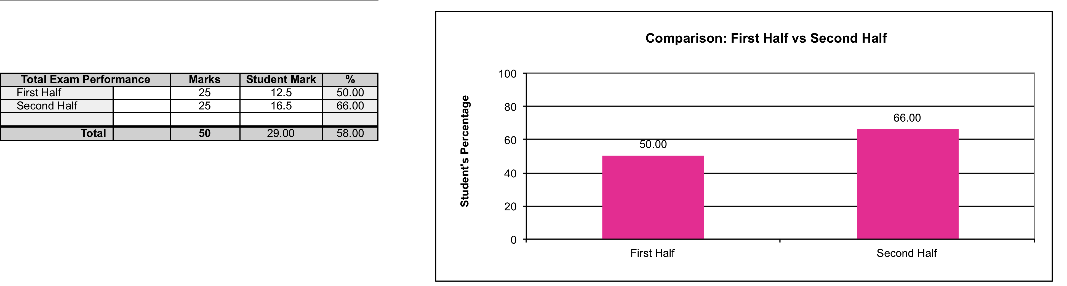
Looking at this SPAG, you can see a significant difference in William’s performance on the first half of the test (50%) compared to the second half (66%). Without the PASS data analysis, this would not have been evident. This means that William passed the second half of the test. This is a very positive result and should be pointed out to William, because it can help to boost his confidence.
In our experience, poor performance on the first half of the test can be indicative of an anxiety issue. Either the student came to the test in an anxious state or became anxious once they started reading the test. Again, this is a finding that must be explored with William.
Another explanation for this result might be related to our hypothesis in the Class Content category that William performed better on physical science-based content. Perhaps the second half of the test was weighted towards this content.

After reviewing William’s SPAG, we looked at his completed test booklet.
Although we cannot show you William’s completed test booklet, here are the patterns that we discovered:
- Several unanswered questions at the beginning of the test
- Difficulty formulating answers to Communication-type questions (those related to “speaking” to the client)
- Lost marks for answers that were vague and/or incomplete
Having reviewed William’s SPAG and completed test booklet, let us recap his overall performance on Test 1. He received a grade of 58%, which is close to a passing grade. Although there are many areas that need improvement, by analyzing and interpreting the SPAG we found that William demonstrates a number of strengths that we can use to build his Action Plan.
Strengths | Areas to improve | Areas to explore with William
Strong performance on physical science-based content (70%–88%)  Basic nursing knowledge upon which to build  Passing grade on Scientific Field of Knowledge (60%)  Passing grade on the simpler-level questions of Bloom’s Taxonomy (69% and 63%)  Passing grade on second half of test (66%) | Application of knowledge:  - Assessment-type questions (53%)  - Intervention-type questions (57%)  - Apply-level questions (52%)  Communication Field of Knowledge (50%); difficulty with Communication-type questions (those related to “speaking” to the client) | Performance on first half of test (50%); several unanswered questions at beginning of test  Lost marks for vague and/or incomplete answers
We will use this summary to guide us in building an Action Plan for William.
However, before building the Action Plan, we need to review the data from the Complementary Assessment Tools. See William’s completed forms and our interpretation of them.

Student Profile
Name William Date October 15, 2016
Year graduated high school 2015 Current Nursing course Nursing 180-XXX
Were you registered in another program before nursing? No Yes (which one?)
Language
Mother tongue English Other languages spoken French
Language of previous schooling English and French
Fluency in oral English poor moderate fluent
Fluency in written English poor moderate fluent
Fluency in English listening skills poor moderate fluent
Fluency in English reading skills poor moderate fluent
Proficiency in Sciences
Previous studies (average mark) 85% Nursing Program (average mark) 71%
Present course load
No. of courses full course load
Other time commitments (hours/week)
Family only child Work 26 hours Other go out with friends
Personal experience related to test-taking
Describe briefly how you prepare for your nursing tests.
I try to go to class – have missed a few. Read the teacher’s notes. I try to read the text before class but run out of time.
I tried a study group but did not have time to meet
Rate your level of anxiety in regards to writing nursing tests.
Low 0 1 2 3 4 5 6 7 8 9 10 High
Are you aware of the following college resources?
Counselling Financial aid Learning Center Tutor/Mentor College Nurse
Other
What factors do you think contributed to your test mark?
Don’t know – school was always easy for me. Always did well, and then I failed a nursing test in first year. I passed first year but my marks in nursing are going down. Now I’m scared I could fail the course and it’s freaking me out.

Student Profile –
Teacher’s Guide to Interpreting the Data
Recall that William grew up in an Anglophone family in Montreal and completed all his schooling in French immersion. He was successful in school and knew from a young age that he wanted to have a career in health care. He was accepted into the Nursing program directly from high school.
Having reviewed William’s Student Profile, we saw the following factors as areas of concern:
- Present course load
- Other time commitments
Personal experiences related to test-taking
When we sat down with William and explored the above factors, this is what he told us.
Present course load
He was taking a full course load, which totalled 33 hours per week.
Other time commitments
He was working in a convenience store 26 hours per week: two 8-hour shifts on the weekend and 10 hours during the week, which varied. He was an only child and his parents did not demand a lot from him in terms of chores. He played hockey weekly and liked to “hang out” with his friends on the weekend.
Personal experiences related to test-taking
Describe briefly how you prepare for your nursing tests.
Although successful with tests before college, William was struggling with his academic marks in Nursing. He had difficulty in his first year of Nursing, failing a test for the first time ever. Although he passed the year, he saw a downward trend in his marks. Now in his third semester of Nursing, he is afraid he will fail the course.
Rate your level of anxiety with regard to writing nursing tests.
William rated his anxiety at 8 out of 10. This will require follow-up.
Conclusion
We found William to be an active, engaged young man who was facing the possibility of academic failure for the first time in his life. One issue was time management. Because he had never needed to schedule study time before and was not used to it, he was falling behind in his school work. The other issue was confidence. Having failed a test for the first time ever, he developed anxiety in the face of test-taking, which contributed to this downward trend.
This is another source of data that will be used to build William’s Action Plan.

Study Habits Checklist
Rarely/Never = 0 points Sometimes = 3 points Often/Always = 5 points
0 3 5
In class
- I make every effort to attend all of my classes.
- I take notes while the teacher is talking.
- If a concept is unclear, I take the initiative to ask for help,
in class or afterwards.
Reading and reviewing
- Before lectures, I prepare by reading any assigned material
being covered that day.
- I make notes while reading the assigned material.
- I make diagrams of relationships in the material.
- I read actively, by asking myself questions.
Goal-setting/planning
- I make a study schedule and allot time for all my tasks.
- I break down my long study assignments into several sessions.
- I keep a record of completed tasks.
- I keep a record of outstanding tasks.
Studying
- I review my nursing content every day.
- I summarize material in my own words to understand it better.
- As I study, I use self-instruction by verbalizing my understanding
of what I am learning.
- I use different strategies for recording information:
cue cards, concept mapping.
- I use a nursing/medical dictionary when studying
- I begin studying at least two weeks before the exam.
- I study in a quiet area, free from distractions.
- I seek help by reviewing the material with a friend, study buddy,
study group, or nursing peer tutor.
Preparing for exams
- I organize myself by making an outline of all the important material
I need to learn for an exam.
- I answer all the learning outcomes in my Nursing Course manual.
- I put off my social life until my studying is complete.
- I limit the number of hours I work in my paid job.
- I make up my own case studies.
- I work through a case study before looking at the answer.
- I get plenty of sleep and eat a good breakfast before an exam.
Taking exams
- I write down any abbreviations or key information
on the back of the exam.
- I underline key words and phrases in the case study
and the test question, then verify my answer
before moving on to the next question.
- When I don’t know the answer, I move on to the next question.
- Before the time is up, I go back to any missed questions.
- I accurately predict my exam scores.
- I observe and keep track of my exam performances
and the impact on my grades.
Total score: 83 /160
0–100 Your study skills could use some work! Seek help for tips on how to study more productively and effectively. Take the opportunity to review your tests and gain strategies for how to answer test questions.
101–130 You have some good study habits but there are areas that need work. If you think your marks could be better, seek help in order to develop additional studying and goal-setting strategies.
131–160 You have good study skills overall. If you ever find yourself in trouble when preparing for tests and exams, or with material for a particular course, seek help from your school’s Learning Centre.
Study Habits Checklist score: 83
How you think you did on the test: 67%
Test mark: 58%

Study Habits Checklist –
Teacher’s Guide to Interpreting the Data
Recall that William grew up in an Anglophone family in Montreal and completed all his schooling in French immersion. He was successful in school and knew from a young age that he wanted to have a career in health care. He was accepted into the Nursing program directly from high school.
Before meeting with William, we reviewed his Study Habits Checklist and put together some ideas about what we thought was happening with him. When we sat down to talk with him, we kept in mind that this was a collaborative process. We needed to validate with him our initial ideas and learn more about his reality.
Step 1 We looked at his overall score, which was 83/160.
This puts William in the lowest category. His study skills need improvement.
Step 2 We looked at William’s individual habit scores where he checked off 0s (Rarely/never) and 3s (Sometimes).
Using the knowledge gained from the Student Profile, we recognized that William had difficulties with Present course load, Other time commitments and Personal experiences related to test-taking. Combining this with our expertise as third-semester teachers, we followed up on the areas that were congruent with what we already knew about William and where we would be able to offer strategies.
Reading and reviewing
* Before lectures, I prepare by reading any assigned material being covered that day. (Rarely/never)
* I make notes while reading the assigned material. (Rarely/never)
William validated that he had difficulty developing these habits because there were not enough hours in the day due to his busy school and job schedule.
Goal-setting/planning
* I make a study schedule and allot time for all my tasks. (Sometimes)
* I break down my long study assignments into several sessions. (Rarely/never)
* I keep a record of completed tasks. (Rarely/never)
* I keep a record of outstanding tasks. (Rarely/never)
We assumed that William had never developed strong study skills because success came easy to him. Before acting on this assumption, we needed to discuss it with him. William disagreed. He felt that his study skills must have been good because he had always been successful. However, he admitted that what he was doing was no longer working for him.
Studying
* I begin studying at least two weeks prior to the exam. (Sometimes) – We thought this habit was likely due to a combination of factors: difficulty managing a full course load, work hours, and social commitments; increasing level of complexity in second-year nursing.
Preparing for exams
* I put off my social life until my studying is completed. (Rarely/never)
* I limit the number of work hours in my job. (Rarely/never)
* I get plenty of sleep and eat a good breakfast before an exam. (Rarely/never) – William confirmed that he didn’t always prioritize his school work over his paid work and his social life.
Here are two examples of individual study habits where William scored 0 or 3 but which were not applicable to his situation:
In class
* I make every effort to attend all my classes. (Sometimes) – We thought that his attendance would improve once he learned how to better organize his schedule.
Studying
* I use different strategies for recording information: cue cards, concept mapping. (Rarely/never) – William does not have a problem learning and does not need to spend time learning new study methods.
Step 3 (Optional) We asked William how he thought he had scored on the test. He had expected a higher mark than he received, 67% versus 58%. This puts him in Scenario B.
Scenario B: The student predicted a higher score than he received. The student may not have insight into what he does know and does not know. This is the time to acknowledge the need for change in order to improve.
Although William thought he would do better in his test than he did, he is nonetheless showing some insight. He acknowledges that he is not where he wants to be in the course and that perhaps he lacks the study skills he needs. He also acknowledges that he does not always prioritize his school work over other commitments. Because he recognizes the need for change, he has the potential to improve.
Conclusion
This additional source of data will be used in building William’s Action Plan. Our strategies with William should focus on time management.
Identifying Your Learning Style
Students learn in many ways: by seeing and hearing, by thinking and acting, by reasoning logically and intuitively, by memorizing and visualizing. The ways in which a person typically acquires, retains, and retrieves information are together called the individual’s learning style.
As you complete the checklist, consider the following questions:
What type of information makes the greatest impact on me?
How do I receive, process, and understand information most effectively?

Sensory
I tend to remember what I hear, see, taste, smell, and feel.
I am organized and good with facts and details.
I am slow and meticulous and sometimes I have difficulty understanding theoretical concepts that are not grounded in the real world.
I have some perfectionistic tendencies.

Visual
I remember best what I see.
I prefer teachers who write a lot on the board rather than those who just talk a lot.
When I get directions to a new place, I prefer to be given a map rather than written instructions

Active
I learn best by talking about the information in some way or testing it out in a practical setting.
I excel in group work.
I sometimes act impulsively without thinking about the possible consequences.

Sequential
I learn best in a logical, step-by-step manner.
I must complete one thing before moving on to another.
If I get stuck on one thing, I have difficulty moving on to other things.

Intuitive
I see endless possibilities and sometimes have difficulty getting started on papers because I have so many ideas.
I am creative and innovative.
I am sometimes careless with details and bored by repetition.

Verbal
I remember best what I hear or read.
I sometimes have difficulty understanding graphs and diagrams.
I need to talk or write about ideas to really understand them.

Reflective
I learn best by carefully thinking through a problem or issue before doing anything.
I am an independent learner, able to concentrate well and think things through.
I dislike working in groups.

Global
I learn in large leaps – all of a sudden, I “get it”!
I need to understand the entire picture before I can make sense of the details.
I learn by connecting material to prior knowledge and experience.

Strategies
Identify the strategies that you find helpful in your studying:

Sensory
Relating theories to real-world experiences
Not getting bogged down in details
Summarizing information
Trying new ways of working – brainstorming

Visual
Finding and making diagrams, sketches, concept maps, or time lines that correspond to ideas in the class material
Colour-coding and highlighting the main ideas

Active
Reading actively: taking notes and asking questions as you read
Studying in groups
Teaching someone
Finding ways to use the information you are learning

Sequential
Outlining course material before class – previewing course material
Building on past learning – learning by analogy
Asking the instructor to fill in skipped steps

Intuitive
Asking for interpretations
Finding examples for theories and linking theories to facts
Filling in missing details and giving examples
Reading questions attentively to making sure you’ve understood them properly
Limiting the scope of your research
Double-checking your work

Verbal
Summarizing and outlining course material using your own words
Working in groups, which enables you to listen to others and explain to others

Reflective
Reviewing notes
Trying to speak up more
Summarizing information in your own words
Doing the reading before the class to give yourself time to reflect on the material
Thinking of practical applications

Global
Getting an overview of chapter, course material
Concentrating on one subject at a time
Relating the subject to things you know
Developing a structure in order to organize

Identifying Your Learning Style –
Teacher’s Guide to Interpreting the Data
Recall that William grew up in an Anglophone family in Montreal and completed all his schooling in French immersion. He was successful in school and knew from a young age that he wanted to have a career in health care. He was accepted into the Nursing program directly from high school.
When we sat down with William to review his Identifying Your Learning Style assessment tool, we kept in mind that this was a collaborative process.
Step 1 In looking at the data from William’s completed Identifying Your Learning Style assessment tool, we determined that he was predominantly Active and Global, with a touch of Intuitive and Verbal (in that order).
Step 2 Considering William’s predominant learning styles (Active and Global), we compared what he identified as helpful with the associated strategies for each of his learning styles. William reported finding a variety of strategies helpful. It occurred to us that perhaps the reason why he was having difficulty was that some of the strategies he was using were not congruent with his learning styles. For example, although he seemed to be an Active learner, he was using strategies better suited to a Sensory or Reflective learner.
Step 3 This is discussion time. We started by showing William that half of the strategies he found helpful did not fit with his learning styles. This is not a problem in and of itself: all learning strategies can be useful. However, given that William was having difficulty with his written tests, something had to change. William needed to learn how to tap into strategies that work best with his learning styles.
Active
* Reading actively: take notes and ask questions as you read. – William stated that he did not have the time to take notes and ask questions as he read, because of his full course load and work commitments. We thought that this was a contributing factor to his not doing well on tests. He was likely missing some data needed to answer clinical situation questions in sufficient detail.
* Studying in groups. – William stated he did not have time to participate in study groups as often as he would like. We pointed out to him that he had identified Teaching someone (under the Active learning style) as a helpful strategy and that studying in groups provides an excellent opportunity for this.
Global
* Developing a structure to organize information. – William stated that he had never thought about studying this way. Although it will take time for William to learn how to organize class material in a structured fashion, it will benefit him in the long run.
Step 4 In addition to the strategies compatible with William’s identified learning styles, we discussed the following:
Sensory
* Not getting bogged down in details. – We wished to discuss this with William, as he had chosen it as a helpful strategy. This concerned us because we wanted him to focus more on details, as discussed under Active strategies.
William told us that this strategy had always worked for him in the past. However, considering that clinical situations in nursing are all about details, this strategy would have to change.
Conclusion
Our main focus with William will be on the additional strategies that are suited to his predominant learning styles: Active and Global. In addition, we want him to see him develop more attention to detail.
Now that we have an overview of William’s situation, we can start building his Action Plan.
Summary of Student Assessment Data Worksheet
Our comments are in bold.
SPAG | Student Profile | Study Habits Checklist
Strong performance on physical science-based content (70%–88%)  Difficulty with human science-based content (30%–50%)  Failing grade on Assessment-type questions (53%)  Failing grade on Intervention-type questions (57%)  Passing grade on Scientific Field of Knowledge (60%)  Failing grade on Communication Field of Knowledge (50%)  Passing grade on simpler-level questions (69%–63%)  Failing grade on apply-level questions (52%)  Failing grade on first half of test (50%)  Passing grade on second half of test (66%)  Basic nursing knowledge on which to build (58% on test)  His performance on the human science-based content and Communication Field of Knowledge may be related to a maturity issue (young student being exposed to new knowledge and experiences) | Strong science background  Time commitments:  - Full course load (33 hours/week)  - Works 26 hours/week: two 8-hour shifts on the weekend and 10 hours during the week  - Plays hockey weekly  Likes to “hang out” with friends on the weekend  Previously he never needed to schedule study time but now he is falling behind in his studies  Personal experience related to test-taking, Anxiety: William rated his anxiety at 8/10  Confidence  Failed a nursing test in first year (the first test he ever failed)  Now in danger of failing the course  Has developed anxiety over test-taking due to fear of failure: “I’m scared I’ll fail the course and it’s freaking me out.”  William presents as an active, engaged young man.  Our comments and interpretations are in bold | Score: 83/160  Reading and reviewing  Rarely/never prepares for lectures by reading assigned material  Rarely/never makes notes when he does read assigned material  William validated that this was due to a busy school and work schedule and not enough hours in a day  Goal-setting/planning  Sometimes makes a study schedule and allots time for all tasks  Rarely/never breaks down long study assignments into several sessions  Rarely/never keeps a record of completed tasks  Rarely/never keeps a record of outstanding tasks  We thought he never developed strong study habits because success had always come easy to him. William disagreed, but he did admit that what he was doing was no longer working.  Studying  Sometimes studies at least two weeks before the test  Preparing for exams  Rarely/never puts off social life until studying is completed  Rarely/never limits number of work hours  Rarely/never gets plenty of sleep and eats a good breakfast before a test  William confirmed that he did not always prioritize school work over paid work and social life
Identifying Your Learning Style |  | Completed Test Booklet
Increase use of strategies compatible with his predominant learning styles  Active  Reading actively: take notes and ask questions as you read  William stated he did not have time  Studying in groups  Again, William stated he did not have enough time  Global  Developing a structure in order to organize information  William stated that he never thought about studying this way.  In addition to strategies compatible with his learning styles, we discussed the following:  Sensory  Not getting bogged down in details  William had chosen this as a helpful strategy. This concerned us because we wanted him to focus more on the details. This strategy had worked for him in the past, but clinical situations in nursing studies are all about details. |  | Data from our review of the completed test booklet:  Several unanswered questions at beginning of test  Difficulty with Communication-type questions  Lost marks for vague and/or incomplete answers

Analysis of Student Data Worksheet
Your strengths | Areas to improve |  | Areas to explore together
Strong performance on physical science-based content (70%–88%)  Passing grade on Scientific Field of Knowledge (60%)  Passing grade on the simpler-level questions of Bloom’s Taxonomy (69% and 63%)  Passing grade on the second half of test (66%)  Basic nursing knowledge upon which to build (58% on test)  Strong science background  Active and engaged | Application of knowledge  - Assessment-type questions (53%)  - Intervention-type questions (57%)  - Apply-level questions (52%)  Communication Field of Knowledge (50%) – difficulty formulating answers to Communication-type questions (questions related to “speaking” to the client) |  | Performance on first half of test (50%): several unanswered questions at beginning of test  Lost marks for vague and/or incomplete answers  Other time commitments (full course load, job, social life)  Anxiety related to fear of failure
Focus Points for the Action Plan
Focus Points  1. Resetting priorities  2. Reducing anxiety related to fear of failure  3. Improving test-tasking skills |  | Rationale  1. We believe William’s present situation relates mainly to his other time commitments. If he resets his priorities, he should not need a multifaceted plan; this is why we do not directly address many of the identified issues on the Summary of Student Assessment Data Worksheet.  2. We believe this Focus Point also relates to resetting priorities. If William makes a change in his time commitments, he will have more time to prepare, both for class and for tests. Better preparation should improve his performance on tests, resulting in increased confidence and decreased anxiety.  3. As noted in the rationale above, if William has more time to prepare, his test performance should improve. We can focus on test-taking strategies to further build his confidence.

Action Plan
(Immediately following the plan, you will see our rationale for each of the strategies we have suggested for William.)
William, here is a summary of our analysis of your situation.
Your strengths | Areas to improve | Areas to explore together
Strong performance on physical science-based content (70%–88%)  Basic nursing knowledge upon which to build  Passing grade on Scientific Field of Knowledge (60%)  Passing grade on the simpler-level questions of Bloom’s Taxonomy (69% and 63%)  Passing grade on the second half of the test (66%)  Strong performance in Sciences  Active and engaged | Application of knowledge  - Assessment-type questions (53%)  - Intervention-type questions (57%)  - Apply-level questions (52%)  Communication Field of Knowledge (50%) difficulty with Communication-type questions (those related to “speaking” to the client) | Performance on first half of test (50%): several unanswered questions at beginning of test  Lost marks for vague and/or incomplete answers  Other time commitments  Anxiety related to test-taking
Focus Points for your Action Plan
- Resetting priorities
- Reducing anxiety related to fear of failure
- Improving test-taking skills
Before we review your plan with you, we want you to know that we think you are a capable young person with everything you need to be successful. It looks as though, in order to get back on track, you need to make time to do the work.
Your Action Plan
(Remember, this is a first draft of your plan, because, until you meet with the student and include their input, the plan will not be complete.)
1. Resetting priorities
Explore your decision-making with regard to your other time commitments. We think you are unable to prepare for class and tests due to these commitments. However, Nursing is a demanding program. Unless you make a change now, you will likely not be successful in the course.
Decide on your priorities. You realize that what you are currently doing is not working for you; you failed the first test and have developed anxiety over test-taking. We think you need to decide on your priorities and take action. How ready are you to do this?
2. Reducing anxiety related to fear of failure
Link to appropriate resources. You’ve told us that your anxiety is affecting your performance. We think this can be resolved with better preparation and time management. However, we want to raise the possibility of assistance from the Counselling Department, who can help you talk through your fear of failing the course. How do you feel about seeing a counsellor?
Developing a strong knowledge base is the key. Here is what we suggest.
- Prepare for class:
- Make time to read the text according to the Learning Outcomes in the Course Manual
- Review class notes and readings:
- The more you review, the more you retain. You need to use your time more efficiently – for example, is there down time at work when you might be able to review your notes?
- Eat and sleep well:
- A rested, well-nourished brain learns better. If you take care of yourself, you will be better able to do the work that is required of you.
3. Improving test-taking skills
Preparing for the test
- Come prepared:
- Keep up with class material on a weekly basis. This will keep you from falling behind again.
- Make a written schedule to cover all topics and stick to it. You need a written, organized study plan to prepare for the next test (you can refer to the Sample Study Schedule in the Tools section of the PASS website).
- Try to finish all topics one to two days before the test. This should reduce your anxiety and put you in a better frame of mind going into the test.
- Study according to the Learning Outcomes:
- Read your notes; ask to borrow notes for the classes you missed. Reading and studying according to the Learning Outcomes gives you structure and keeps you focused.
- Refer to the text for additional details. You identified Sensory as one of your learning styles. You don’t like to get bogged down in details. However, you need to know that clinical situations in nursing studies are all about the details.
- Take care of yourself:
- Eat well. On the Study Habits Checklist, you said that you don’t get plenty of sleep and eat a good breakfast before a test. Remember, a rested, well-nourished brain performs better.
- Go to bed at a reasonable hour.
- Prepare for the test the same way you prepare for a clinical day. Pack your bag with everything you need. Preparing the night before a test will promote better sleep and reduce anxiety.
Performing on Test Day
- Arrive ahead of time:
- Resist being distracted by friends before entering the room. This should help reduce your anxiety.
- Improve your approach to taking case-based tests:
- Use the information in the clinical situation. You failed the Assessment- and Intervention-type questions. Do you think this is because you just didn’t know the answer or because you didn’t know how to use the information in the clinical situation?
- Read the whole clinical situation through; then highlight, underline, or circle key words.
- Before answering a question, take time to read it and understand what is being asked.
Strategies for Short-Answer Format
- Be as specific as possible. You lost marks for answers that were vague and/or incomplete.

- Write a rough draft of your answer.
- When composing a complicated answer, use the blank back of the test page. You scored only 50% on Communication-type questions and we noticed that you have difficulty with questions related to “speaking” to the client. This strategy will help you practise writing out a client-specific answer.
Here is the rationale for each of the strategies we have suggested for William.
Before we review our Action Plan with William, we want to tell him that we think he is a capable young person with everything he needs to be successful. It looks as though, to get back on track, he needs to make time to do the work.
Rationale: William needs to know that his teachers believe in him. You may notice that we do not directly address many of the identified issues on the Summary of Student Assessment Data Worksheet. This is because we believe his present situation relates mainly to his other time commitments. If he resets his priorities, he should not need a multifaceted plan.
Change in time commitments → more time to prepare → improved performance on tests → increased confidence → decreased anxiety.
1. Resetting priorities
Action Plan | Rationale
Explore your decision-making with regard to your other time commitments  Decide on your priorities | William is unable to prepare for classes and tests in order to be successful in the course. We believe this is due to his numerous other time commitments: as well as being a full-time student, he works 26 hours/week, plays hockey weekly, and likes to socialize on the weekend.  William stated he does not prioritize school work over paid work and social life and does not limit his work hours. He realizes that this pattern is not viable for him: he is failing at school and has developed anxiety around test-taking.  Our proposed action plan is tentative until we know if William can see himself making the necessary changes.
2. Reducing anxiety related to fear of failure
Action Plan | Rationale
Link to appropriate resources  Counselling  Studying – Developing a Strong Knowledge Base  Prepare for class:  - Make time to read the text according to the Learning Outcomes in the Course Manual  Review class notes and readings:  - The more you review, the more you retain  Eat and sleep well:  - A rested, well-nourished brain learns better | We think that William’s issues with anxiety can be resolved with better preparation and time management. However, his anxiety is interfering with his performance. We see it as our responsibility to discuss the possibility of counseling.  We’re confident that William will be successful if he finds time to do the work. Being better prepared should help to reduce his anxiety related to fear of failure.  We want William to make the best use of his time. Therefore, we would explore with him the possibility of using down time at work to review his notes.  We know that William does not have enough time to take care of himself. If he finds time to eat and sleep adequately, this should result in better preparation, improved performance and ultimately, reduced anxiety.

3. Improving test-taking skills
Here is a sample study schedule:
Action Plan | Rationale
Test-Taking – Preparing for the Test  Come prepared:  - Keep up with class material on a weekly basis  - Make a written schedule to cover all topics, and stick to it  - Try to finish all topics one to two days before the test  Study according to the Learning Outcomes:  - Read your notes; ask to borrow notes for the classes you missed  - Refer to the text for additional details  Take care of yourself:  - Eat well  - Go to bed at a reasonable hour  - Prepare for the test the same way you prepare for a clinic day  Test-Taking – Performing on Test Day  Arrive ahead of time:  - Resist being distracted by friends before entering the room  Improve your approach to taking case-based tests:  - Use the information in the clinical situation  - Read the whole clinical situation through; then highlight, underline, or circle key words  - Before answering a question, take the time to read it and understand what is being asked  Test-Taking – Strategies for Short-Answer Format  Be as specific as possible  Write a rough draft of your answer:  - When composing a complicated answer, use the blank back of the test page | William has fallen behind in his studies. To get back on track, he needs to develop an organized plan of study and test preparation.  Finishing all topics on time should reduce his anxiety and put him in a better frame of mind to write the test.  Since we suggested that William prepare for class using the Learning Outcomes, we want him to benefit from that structure.  In the Learning Style, William identified Sensory as one of his learning styles. He likes to “not get bogged down in details.” This concerns us, because nursing case studies are all about details.  On the Study Habits Checklist, William reported that he “Rarely/never gets plenty of sleep and eats a good breakfast before a test”  Being prepared the night before the test should promote better sleep and reduce his anxiety the next morning.  This should help reduce his anxiety.  William received failing grades on both Assessment- and Intervention-type questions. We do not know if this is due to a weak knowledge base or not knowing how to use the information in the clinical situation. This needs to be validated with him. Nonetheless, feeling better equipped with these strategies should increase his confidence in writing the test.  On the test, William lost marks for vague and/or incomplete answers.  William received 50% on Communication-type questions. In reviewing his test, we saw that William had difficulty formulating answers to questions that related to “speaking” to the client. This strategy will help him practise writing out a client-specific answer, using appropriate language.

Week 9
Meet with William
During the discussion with William, we learned that he:
- is willing to reset his priorities, reducing his work hours and limiting his social life until the semester is over; he absolutely wants to succeed in the course.
- agrees with us that his anxiety can be resolved with better preparation and time management but does not want to take the time to see a counsellor, at least for now.
- has no down time at work to review his notes but can reduce his work hours to one day on the weekend.
- thinks his poor performance was due in part to lacking the knowledge needed to answer the questions and sometimes missing important information in the clinical situation.
Having met with William, we completed our Action Plan to include his input. We like to finish with some words of encouragement.

Complete the Action Plan
(This is the copy sent to the student – revisions are written in blue)
William, here is a summary of our analysis of your situation.
Your strengths | Areas to improve | Areas to explore together
Strong performance on physical science-based content (70%–88%)  Basic nursing knowledge upon which to build  Passing grade on Scientific Field of Knowledge (60%)  Passing grade on the simpler-level questions of Bloom’s Taxonomy (69% and 63%)  Passing grade on the second half of the test (66%)  Strong performance in Sciences  Active and engaged | Application of knowledge  - Assessment-type questions (53%)  - Intervention-type questions (57%)  - Apply-level questions (52%)  Communication Field of Knowledge (50%) – difficulty formulating answers to Communication-type questions (those related to “speaking” to the client) | Performance on the first half of the test (50%) – several unanswered questions at beginning of test  Lost marks for vague and/or incomplete answers  Other time commitments  Anxiety related to test-taking
Focus Points for your Action Plan
- Resetting priorities
- Reducing anxiety related to fear of failure
- Improving test-taking skills
Your Action Plan
1. Resetting priorities
Explore your decision-making with regard to your other time commitments. We think you are unable to prepare for class and tests due to your many time commitments. Nursing is a demanding program. Unless you make a change now, you are not likely to be successful in the course.
Decide on your priorities. You realize that what you are currently doing is not working for you: you failed the first test and have developed anxiety over test-taking. We think you need to decide on your priorities and take action. How ready are you to do this?
You acknowledge that Nursing is a demanding program and you absolutely want to succeed. You’ve agreed to reset your priorities by reducing your work hours by one day on the weekend and limiting your social life until the semester is over.
2. Reducing anxiety related to fear of failure
Link to appropriate resources. You’ve told us that your anxiety is affecting your performance. We think this can be resolved with better preparation and time management. However, we want to raise the possibility of help from the Counselling Department, who can help you talk through your fear of failing the course. How do you feel about seeing a counsellor?
You agree that your anxiety can be resolved with better preparation and time management. You don’t want to take the time to see a counsellor, at least for now.
Developing a strong knowledge base is the key. Here is what we suggest.
- Prepare for class:
- Make time to read the text according to the Learning Outcomes in the Course Manual
- Review class notes and readings:
- The more you review, the more you retain. Try to use your time more efficiently – for example, is there down time at work when you might be able to review your notes? You stated that there is no down time at work but you are willing to reduce your work hours by one day every weekend.
- Eat and sleep well:
- A rested, well-nourished brain learns better. If you take care of yourself, you will be better able to do the work that is required of you.
3. Improving test-taking skills
Preparing for the test
- Come prepared:
- Keep up with class material on a weekly basis. This will keep you from falling behind again.
- Make a written schedule to cover all topics and stick to it. You need a written, organized study plan to prepare for the next test (you can refer to the Sample Study Schedule in the Tools section of the PASS website).
- Try to finish all topics one to two days before the test. This should reduce your anxiety and put you in a better frame of mind going into the test.
- Study according to the Learning Outcomes:
- Read your notes; ask to borrow notes for the classes you missed. Reading and studying according to the Learning Outcomes gives you structure and keeps you focused.
- Refer to the text for additional details. You identified Sensory as one of your learning styles. You don’t like to get bogged down in details. However, you need to know that clinical situations in nursing studies are all about the details.
- Take care of yourself:
- Eat well. On the Study Habits Checklist, you said that you don’t sleep well and don’t eat a good breakfast before a test. Remember, a rested, well-nourished brain performs better.
- Go to bed at a reasonable hour.
- Prepare for the test the same way you prepare for a clinic day; pack your bag with everything you need. Being prepared the night before a test should promote better sleep and reduce anxiety.
Performing on Test Day
- Arrive ahead of time:
- Resist being distracted by friends before entering the room. This should help reduce your anxiety.
- Improve your approach to taking case-based tests:
- Use the information in the clinical situation. You failed the Assessment- and Intervention-type questions. Do you think this is because you didn’t know the answer or because you didn’t know how to use the information in the clinical situation? You think your poor performance was due, in part, to lacking the knowledge needed to answer the questions and sometimes missing important information in the clinical situation. Let us add that the information in the clinical situation is there for a reason and your answers need to link to this information.
- Read the whole clinical situation through; then highlight, underline, or circle key words.
- Before answering a question, take time to read it and understand what is being asked.
Strategies for Short-Answer Format
- Be as specific as possible. You lost marks for answers that were vague and/or incomplete.
- Write a rough draft of your answer:
- When composing a complicated answer, use the blank back of the test page. You received only 50% on Communication-type questions and we noticed that you have difficulty formulating answers to questions related to “speaking” to the client. This strategy will help you practise writing out a client-specific answer.

William, we want to remind you that we think you are a capable young person with everything you need to be successful. We think that, to get back on track, you just need to make time to do the work. You are heading in the right direction with the decisions you’ve already made.

Test 2
Week 11
William writes Test 2.
Week 13
We review William’s SPAG from Test 2.
As you can see below, William received a passing grade on the test (67%). Therefore, he has improved his grade by 9% from Test 1. He should be congratulated for the improvement and for receiving a passing grade.
Let us analyze the SPAG more closely.
Class Content
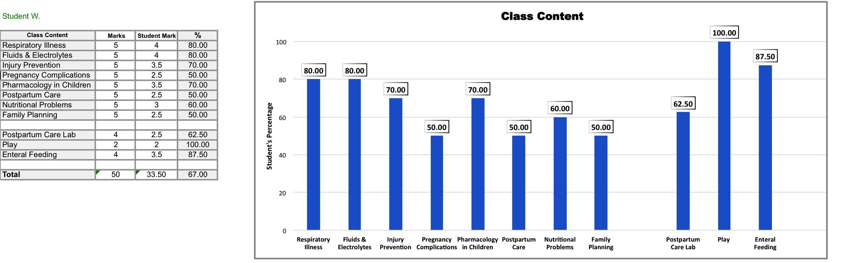
On Test 1, we hypothesized that William’s youth and limited experience in the Perinatal Care and Pediatric Fields of Nursing contributed to his poor performance on human science-based content. However, William’s Test 2 results demonstrate a new pattern. He scored a passing mark (60%–80%) on all of the theory classes related to the Pediatric Field of Nursing (Respiratory Illness, Fluids and Electrolytes, Pharmacology in Children, and Nutritional Problems in Children), whereas he received failing grades (50%) on the theory classes related to the Perinatal Care Field of Nursing (Pregnancy Complications, Postpartum Care, and Family Planning).
What does this mean for us as teachers working with William? First, we need to know about William’s clinical experience in the course: which clinical setting did he start in or is attending currently? It is possible that William has had insufficient opportunity to apply his Perinatal Care theory in the clinical setting. Second, we need to explore William’s comfort level in the Perinatal Care setting. As hypothesized, his youth and limited life experience may be affecting his performance. We will need to discuss this with William.
Professional Component
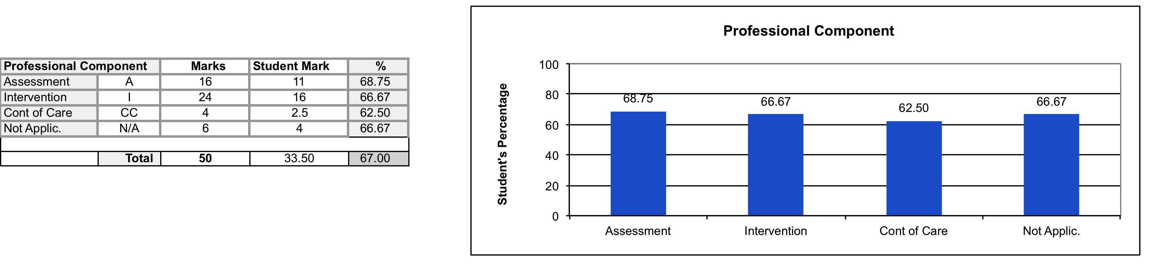
The most significant finding here is that William received a passing grade in all dimensions of the Professional Component. William’s performance on Assessment-type questions (69%) and Intervention-type questions (67%) shows us that he is capable of succeeding in the course. Had he presented these results in Test 1, he may not have been invited to participate in the PASS process.
Functional Component
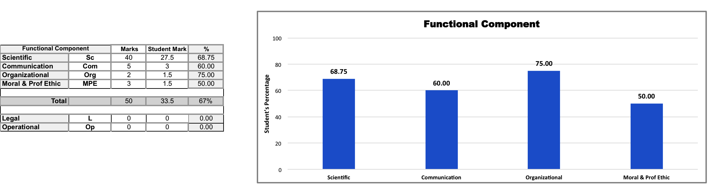
As always, let us start with the Scientific Field of Knowledge, because this is the foundation of nursing practice. The most significant finding in this SPAG is that William scored 69% on the predominant Field of Knowledge on the test (the Scientific Field of Knowledge made up 80% of the test).
Although William scored 75% on the Organizational Field of Knowledge, the test consisted of only two questions. Our focus should be the Communication Field of Knowledge, where he scored 60%. This is important, as it was the second most tested field and should be an area of attention for William.
Bloom’s Taxonomy
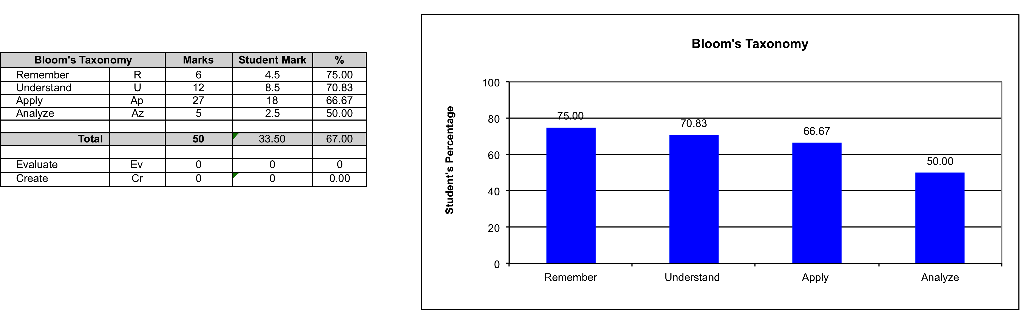
William has passed three of the four levels of questions in Bloom’s Taxonomy, which is a very positive result. However, since the final test in Semester 3 will be largely Apply-level questions, William needs to improve his performance in this area.
William received a mark of 50% on Analyze-level questions, but the test contains only five of these questions. Considering that there are only two weeks remaining in the semester, the short-term goal for William should be improved ability to answer Apply-level questions; Analyze-level questions can wait for now.
Comparison: First Half versus Second Half of Test
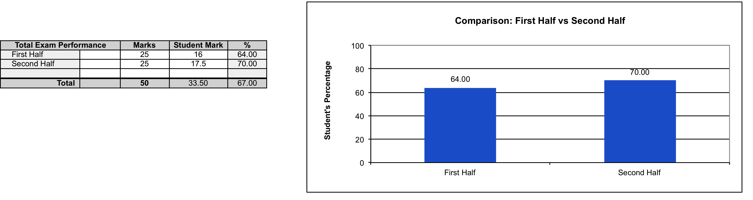
Let us congratulate William for passing both halves of the test and for a fairly strong performance (70%) on the second half. However, his performance on the first half was only 64%. This needs to be explored with William. We did observe that the first half of the test was weighted towards Perinatal Care. This is congruent with our earlier observations, in Content, which demonstrated that William was failing in the area of Perinatal Care.

Analyze and Interpret the Comparison Graphs (Test 1 and Test 2)
Now that we have reviewed William’s SPAG from Test 2, it’s time to compare Test 1 and Test 2 in terms of his performance. The PASS Excel grid can generate graphs for comparing two tests. Remember, we can make comparisons only when the variables within the categories remain the same. We have used the following categories for William: Professional Component, Bloom’s Taxonomy, and First Half versus Second Half of the Test.
Professional Component
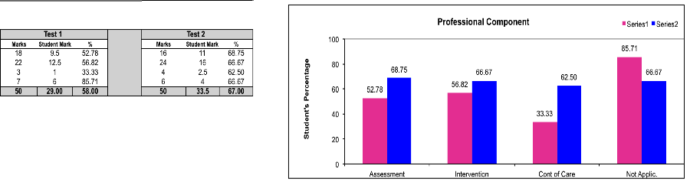
The Comparison Graphs make a big impact on the students. It is easy for William to see that he has made improvements on all three variables that reflect nursing activities: Assessment (16%), Intervention (10%), and Continuity of Care (30%). The main Focus Point of William’s Action Plan was to reset his priorities to make more time for his Nursing course. It appears that his willingness to make the necessary changes has paid off. His improvement in Assessment- and Intervention-type questions is especially significant, because these questions make up the largest portion of most nursing tests.
We have an important point to make. When you look at the SPAG, his greatest improvement is on the Continuity of Care questions (30%). However, Test 2 contained only four of these questions – Continuity of Care questions usually make up the smallest portion of a nursing test. Therefore, although the improvement is impressive on the graph, our focus should remain on helping William to improve his performance on Assessment- and Intervention-type questions.
You can see that his performance actually dropped by 19% in the Not Applicable-type questions. It is difficult to draw conclusions from a catch-all grouping of questions with no particular focus. However, we still need to address this dip in performance with William to pinpoint any problem that might exist.
Bloom’s Taxonomy
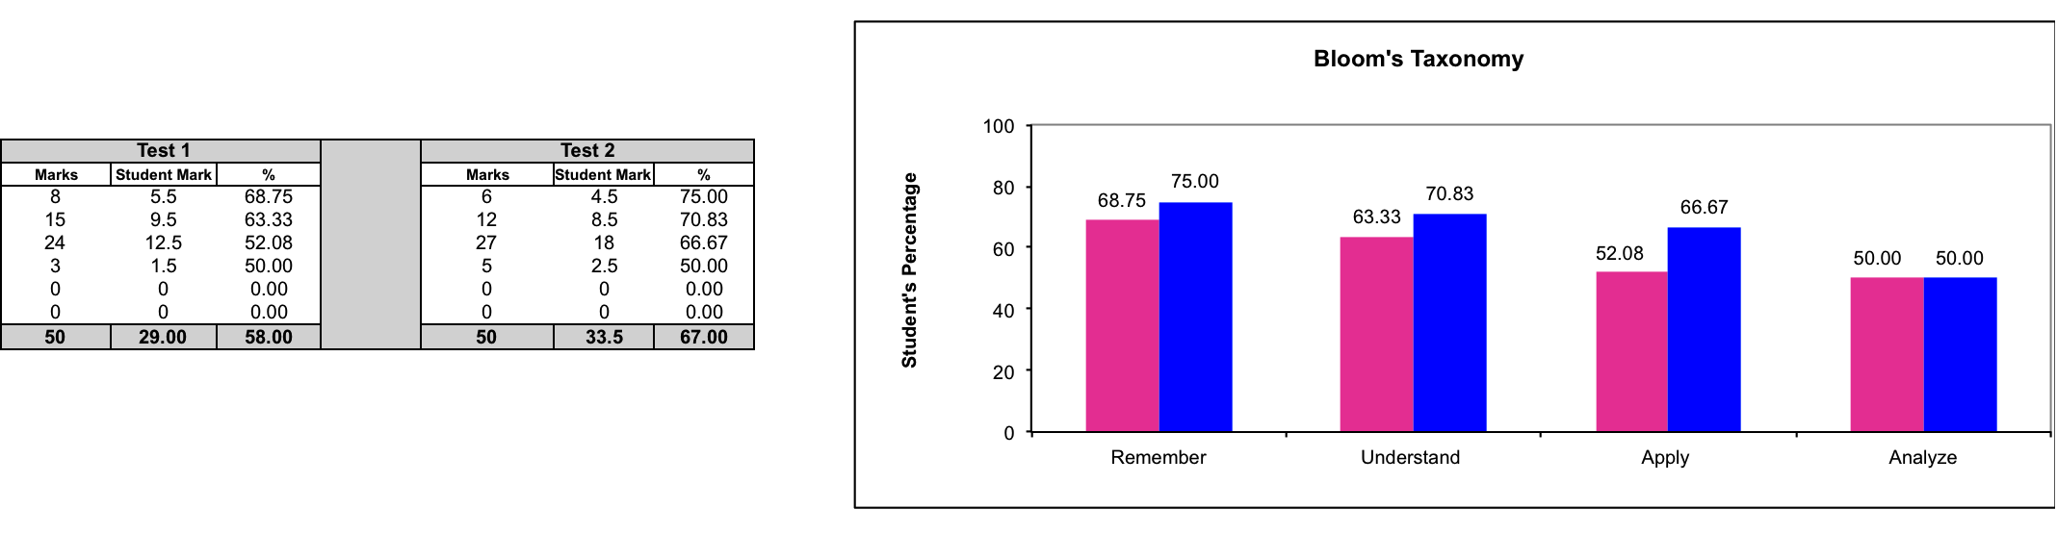
William’s greatest improvement is on Apply-level questions (15%). This is significant, because one focus of his Action Plan was learning to apply his knowledge when answering test questions. In addition, he has improved in both Remember-level (6%) and Understand-level (8%) questions. Since there is no improvement in Analyze-level questions and his performance in Apply-level questions is only at 67%, we will continue to help William improve his performance on the more complex questions.
Comparison: First Half versus Second Half of Test
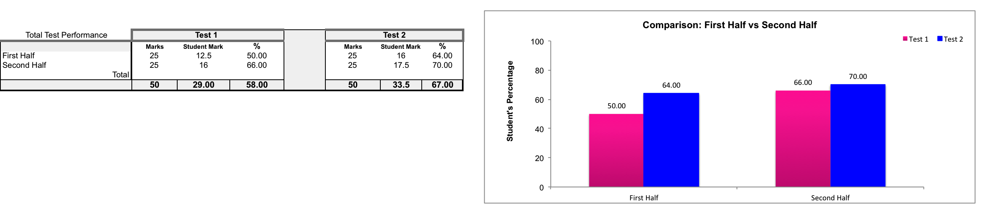
The most important improvement is that William has passed both halves of Test 2. In his Student Profile, he told us that his fear of failure was affecting his performance. Our hypothesis was that William’s anxiety could be resolved with better preparation and time management. It appears that the strategies from his Action Plan are working, but we have to validate with him that he actually made the changes.
Reviewing William’s completed test booklet
Although we cannot show you William’s completed test booklet, this is the additional information that we gathered:
- Unlike in Test 1, William answered all the questions
- Still lost marks for answers that were vague and/or incomplete

Update the Action Plan – Test 2
This is our Analysis of Data for William.
Areas improved | Areas to improve | Areas to explore together
Assessment-type questions:  Test 1 53%, Test 2 69% (↑16%)  Intervention-type questions:  Test 1 57%, Test 2 67% (↑10%)  Scientific Field of Knowledge:  Test 1 60%, Test 2 69% (↑ 9%)  Remember-type questions:  Test 1 69%, Test 2 75% (↑ 6%)  Understand-type questions:  Test 1 63%, Test 2 71% (↑ 8%)  Apply-level questions:  Test 1 52%, Test 2 67% (↑15%)  Passing grade on both halves of test | Communication Field of Knowledge (60%) – difficulty formulating answers to Communication-type questions (those related to “speaking” to the client)  Answering more complex questions:  - Apply-level  - Analyze-level | Still lost marks for vague and/or incomplete answers  New Finding: passing grade on Pediatric Content and failing grade on Perinatal Care Content
Focus Points for your Action Plan
- Resetting priorities
- Reducing anxiety related to fear of failure
- Improving test-taking skills
Your Action Plan
Note to readers: The questions in italics are meant as discussion points for our talks with William. The final Action Plan is based on his answers. You will see the final Action Plan following this draft.
1. Resetting priorities
With regard to resetting your priorities, what changes have you made? It looks as though the changes you have made are working.
2. Reducing anxiety related to fear of failure
You previously rated your anxiety at 8 out of 10. Where would you rate it now?
We have noticed that you are performing better on the Pediatric content as compared to the Perinatal Care content. What do you think about this?
3. Improving test-taking skills
Preparing for the test
- Practise answering sample questions.
- Answer any sample questions or tests that you have access to in the course. The more you practise answering questions based on clinical situations, the better you will become at identifying key information in a clinical situation. Ultimately, you will become better at formulating answers that are directly related to the clinical situation.
Strategies for Short-Answer Format
We noticed that you are still losing marks for vague and/or incomplete answers. Also, you are still struggling with Communication-type questions. What do you think about this?
We want to reinforce the following strategies:
- Be as specific as possible.
- Write a rough draft of your answer:
- When composing a complicated answer, use the blank back of the test page. You scored only 60% on Communication-type questions and we noticed that you have difficulty answering questions where you need to “speak” to the client. This strategy will help you practise writing out a client-specific answer.
Meet William
While validating our analysis with William, we learned that he:
- had stopped working on Sundays and limited his outings with friends to weekends, which gave him more time to study.
- felt better prepared before Test 2, rating his anxiety at 5 out of 10, and felt better while writing the test.
- had not noticed that he performed better on Pediatric content than on Perinatal Care content; he stated that he is more interested in Pediatric content and spends more time on it – does not see himself ever working in Perinatal Care .
- is trying to use the nursing vocabulary that he is learning but is having trouble adapting the answer when speaking to or teaching the client.
This information will be used to finalize William’s Action Plan.

Send the finalized Action Plan to William
Revisions are written in blue
Areas improved | Areas to improve | Areas to explore together
Assessment-type questions:  Test 1 53%, Test 2 69% (↑16%)  Intervention-type questions:  Test 1 57%, Test 2 67% (↑10%)  Scientific Field of Knowledge:  Test 1 60%, Test 2 69% (↑ 9%)  Remember-type questions:  Test 1 69%, Test 2 75% (↑ 6%)  Understand-type questions:  Test 1 63%, Test 2 71% (↑ 8%)  Apply-level questions:  Test 1 52%, Test 2 67% (↑15%)  Passing grade on both halves of test | Communication Field of Knowledge (60%) – difficulty formulating answers to Communication-type questions (those related to “speaking” to the client)  Answering more complex questions:  - Apply-level  - Analyze-level | Still lost marks for vague and/or incomplete answers  New Finding: passing grade on Pediatric Content and failing grade on Perinatal Care Content
Focus Points for your Action Plan
- Resetting priorities
- Reducing anxiety related to fear of failure
- Improving test-taking skills
Your Action Plan
1. Resetting priorities
You have said that you have stopped working on Sundays and have limited your outings with friends to weekends. This has given you more time to study. The end of semester is coming up quickly. It appears that the changes you have made are working and we encourage you to keep them up!
2. Reducing anxiety related to fear of failure
You have stated that you felt better prepared before Test 2 and you rated your anxiety at 5 out of 10. You also felt better writing the test. It seems obvious that being better prepared helped to decrease your anxiety before and during the test. We hope this has given you the confidence to continue what you are doing, knowing that it is helping you.
You have said that you are less interested in Perinatal Care content and are therefore spending less time studying this content. You don’t see yourself ever working in this setting. Nonetheless, for the purposes of this course, improving your performance on Perinatal Care content will improve your overall final mark.
3. Improving test-taking skills
Preparing for the test
- Practise answering sample questions.
- Answer any sample questions or tests that you have access to in the course. The more you practise answering questions based on clinical situations, the better you will become at identifying key information in a clinical situation. Ultimately, you will become better at formulating answers that are directly related to the clinical situation.
You are trying to use the nursing vocabulary that you are learning but are having trouble adapting the answer when speaking to or teaching the client.
Strategies for Short-Answer Format
We want to reinforce the following strategies:
- Be as specific as possible. We noticed that you are still losing marks for vague and/or incomplete answers.
- Write a rough draft of your answer:
- When composing a complicated answer, use the blank back of the test page. You scored only 60% on Communication-type questions and we noticed that you have difficulty answering questions where you need to “speak” to the client. This strategy will help you practise writing out a client-specific answer.
Congratulations, William! The changes you have made have been worth it! You have achieved a 9% improvement from Test 1 and you passed Test 2. You improved by 16% on Assessment-type questions and 15% on Apply-level questions. This is a remarkable accomplishment. Continue what you are doing and try to practise with more sample questions. Good luck on the final test.

